HOW TO MEASURE YOUR STAIRCASE FOR A STAIRLIFT

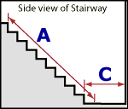 | 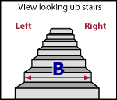 | 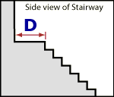
{ 1EXAMPLE MEASUREMENT FORM
MEASUREMENT CHART
A - Overall Length of Stairway inches
This should be a straight measurement from the nose of the top step to the floor, at the foot of the stairway. (see Figure 1)
B - Stairway Width inches
You many find that your stairway width varies a little, over the length of the stairway.
Record the measurement at its narrowest point. (see Figure 2)
C - Clearance at Bottom of Stairway inches
A minimum of 24" is required for this measurement. (see Figure 1)
D - Clearance at Top of Stairway inches
Measure the distance from the nose of the top landing to the nearest obstruction. (see Figure 3)
E - Number of Steps
Include the top landing. (see Figure 2)
F - Mount on LEFT or RIGHT side?
Determine from bottom of stairway looking up. (see Figure 2. )
*Please also indicate if the staircase construction is “TIMBER” (wood) OR “CONCRETE”.

